**Section 3.1:**

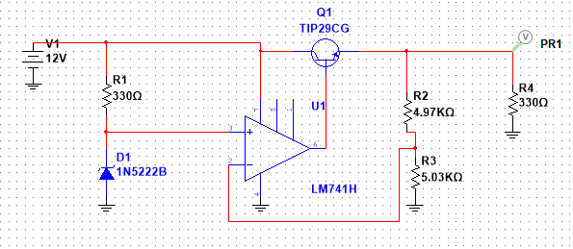

2. R1 = 4.97K R2=5.03K

3.Sweep of the input voltage Vin from 0 − 30 V

(a) Drop Out Voltage = 1.54V. When input voltage is 6.54V output begins to flatten out close to 5V at this point.

(b)Output voltage vs. input voltage sweep from 0 to 30V

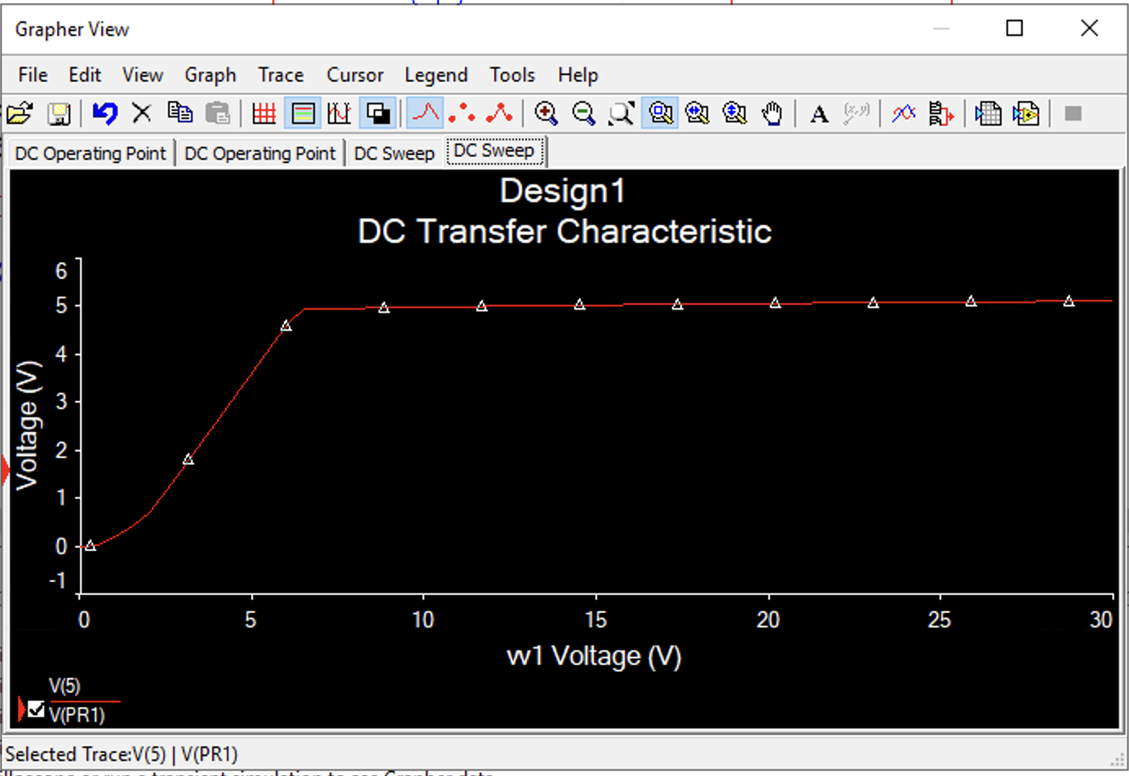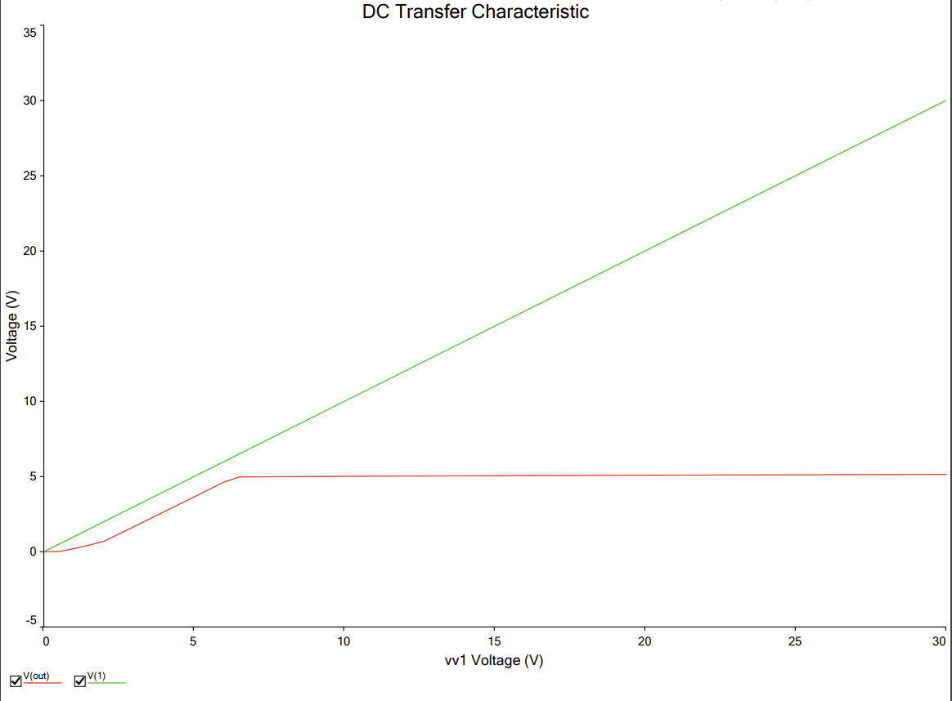

———*————*_

(c)input voltage fixed to 12 V, sweep of the load resistance from 5 Ω to 1000 Ω. Plot is

the output voltage as a function of load resistance

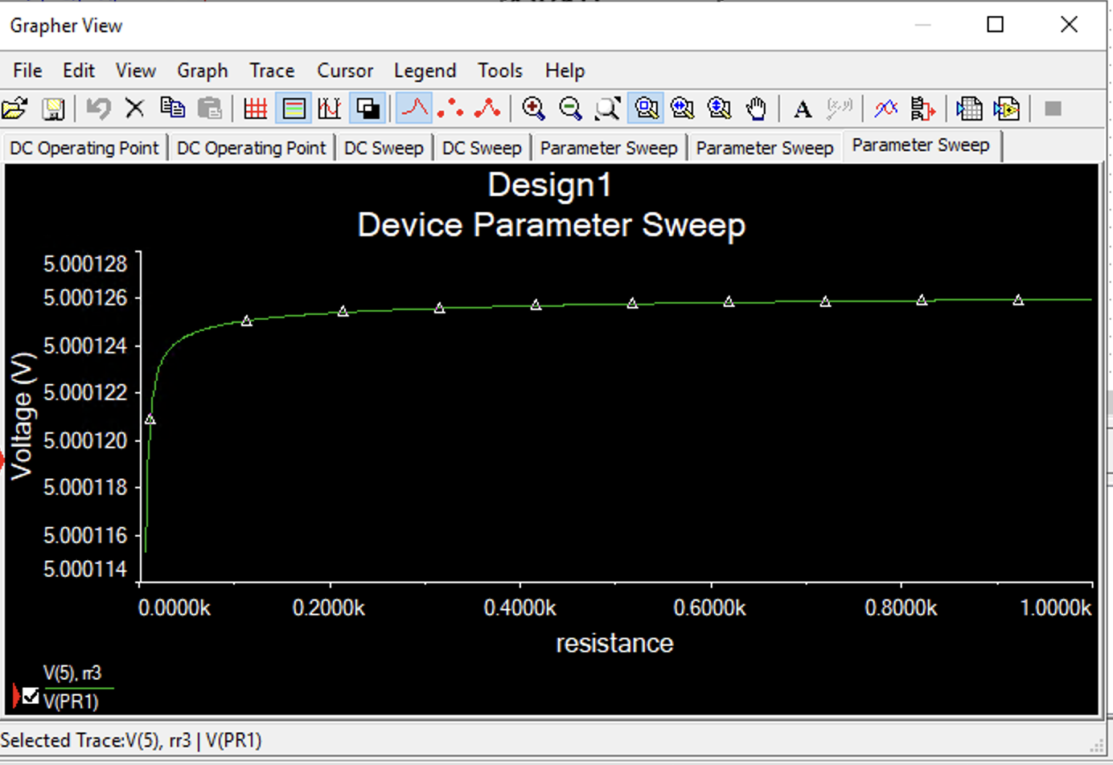

(d)Vregulation at r = 5ohm is 2.26u.

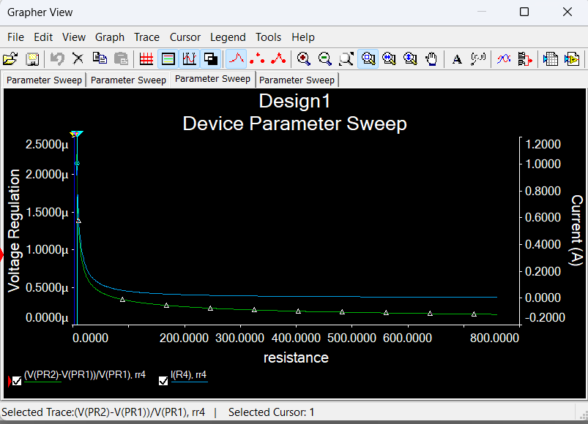

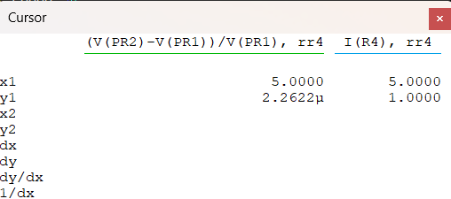

**Section 3.2:**

1.

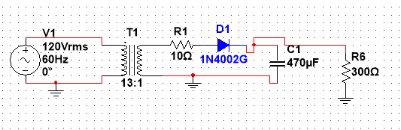

2. 922 mVpp Variation

The plot is output of halfwave peak rectifier circuit output in green. There is a 922 mVpp variation in the output.

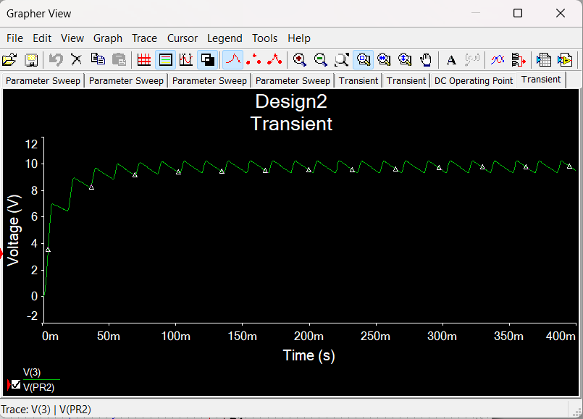

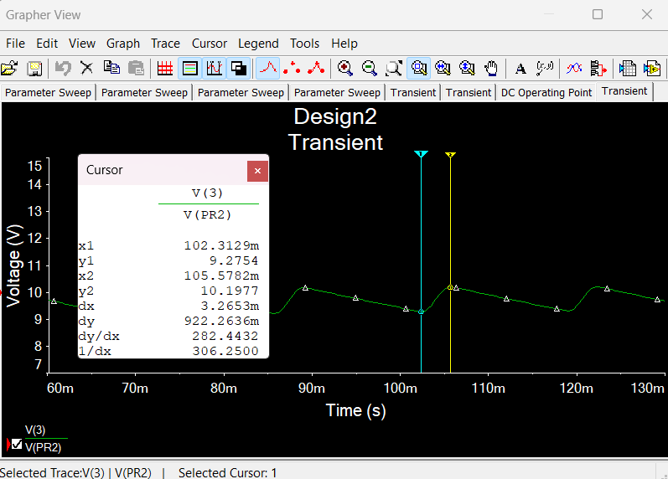

3. The halfwave peak rectifier is connected to the voltage regulator. The green is the output of the regulator. The Vpp variation is now 11.1 mV.

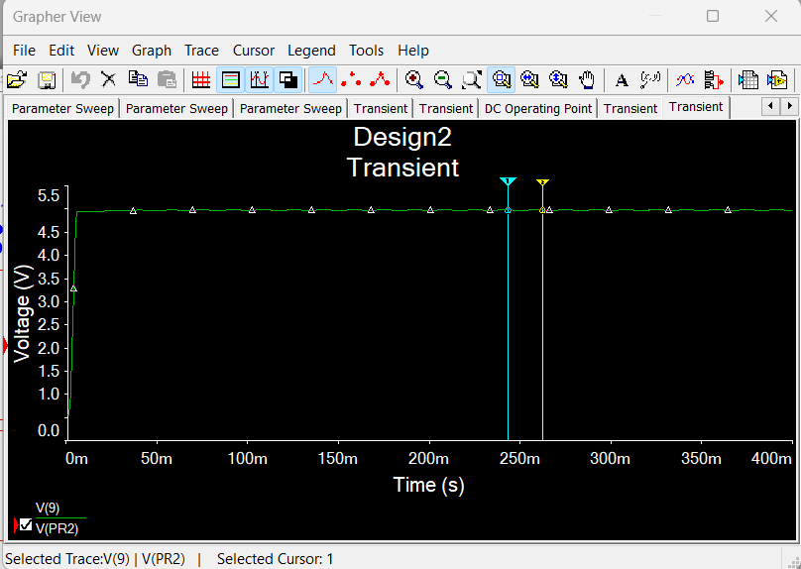

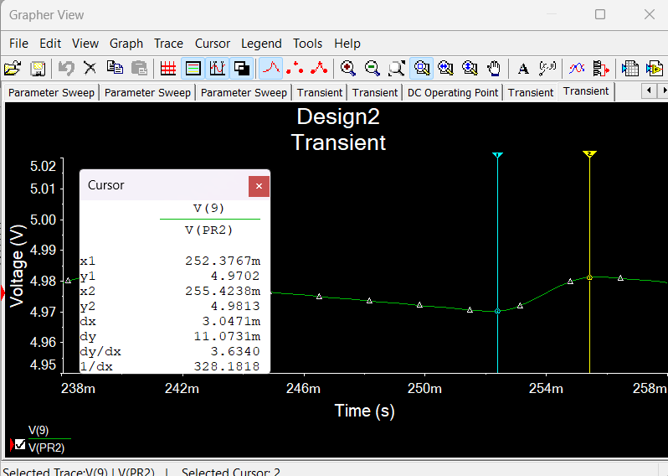

4. Vpp without regulator = 922 mV, 9.45% of 9.76V dc output

With regulator = 11.1 mV, 0.222% of 5V dc output

There is a great improvement in the variation with the regulator. The regulator only has 0.222% variation.

**Section 5.0:**

**DC Testing:**  
Step 5. Inverting 2.526 V, Non-Inverting 2.526 V. It’s the same as our expectation. It follows the   
ideal op amp characteristic when Vn = Vp.

Step 7.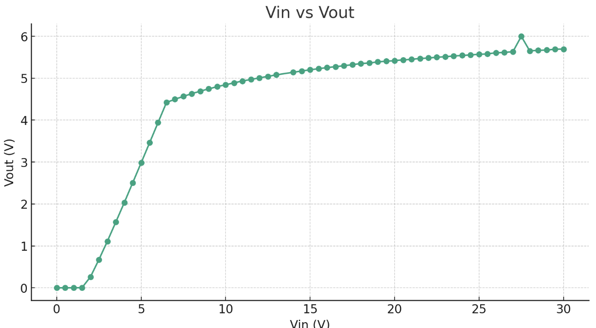  
**AC Testing:**

Step 3 & 4:

Input Signal: Vpp = 2.09V, Vp =1.045, Vrms = 739mV

Output Signal: Vpp = 209mV, Vp = 104.5mV, Vrms = 73.9mV

3.c) Green is input voltage from the adapter, Yellow is the output from the regulator

The regulator has decreased the variations by a factor of 10, therefore it provides a more stable supply which is an improvement.

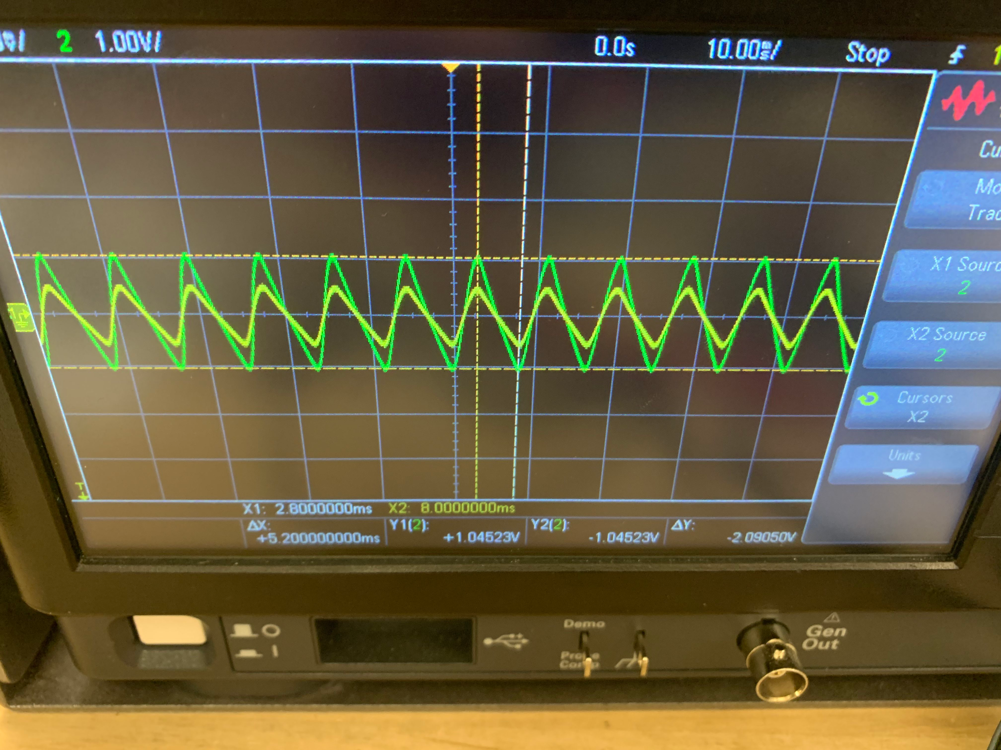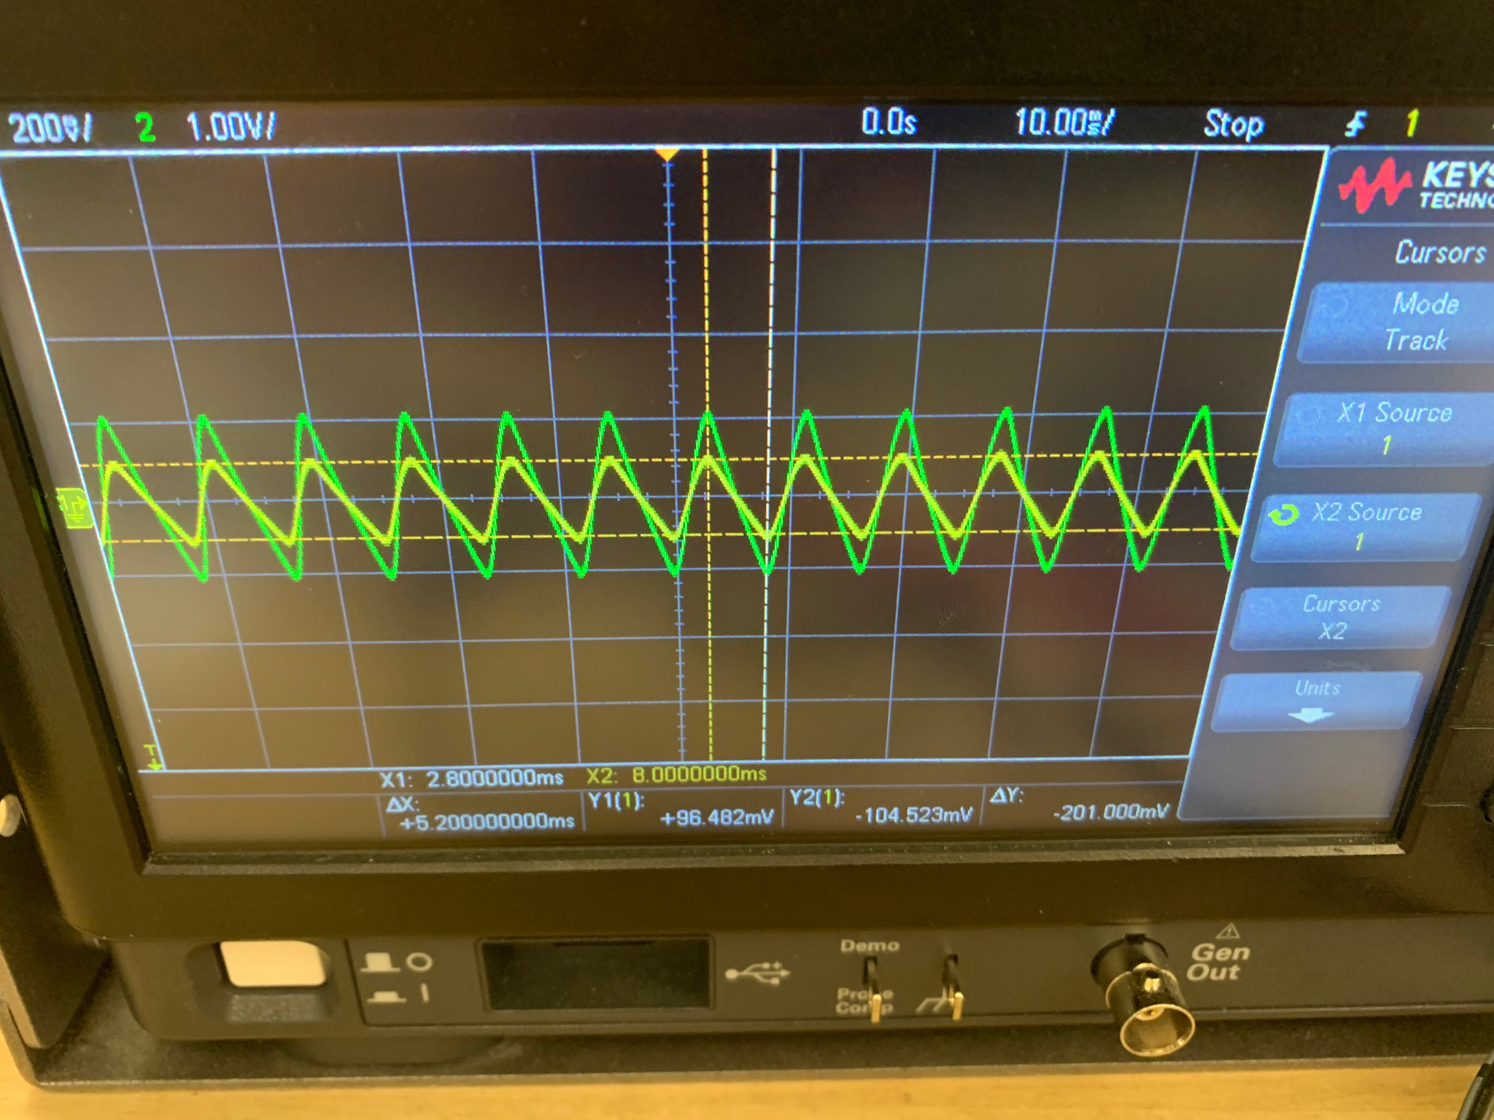

Step 5:

VDC of input = 9.728 V

VDC of output = 4.746V

Vrms of Input = 631.5mV  
Vrms of Output = 64.4mV

They are close but not exactly the same, the multimeter is measuring a lower value for both, for the input, there is a difference of ~100mV for the output there is a difference of ~10mV.